9-11-2018

Brent Schoenmakers

Business case Game sales

Inhoud

2. Introduction 2

2.1 Description of the client 2

2.2 Our team 2

2.3 Planning 2

3.0 Business goal and problem 3

4.0 KPI’s and metrics 5

5.0 Analysis 6

5.1 Assumptions 6

5.2 Scope 6

5.4 Data sources and methods 7

5.5 Cost/ Benefit Analysis 7

5.6 Risk 8

5.7 Conclusion 8

# 2. Introduction

In this chapter I will shortly introduce this document and talk a little about the client in question and who I am. The rest of the document will contain information about how I want to try and find ways to help the organization to grow.

## 2.1 Description of the client

The client in question is a company that is interested in buying stocks from game producers. When saying game producers, think of the likes of Nintendo, Activision, Sony etc. The client has been very successful in the past, investing in the producers that are going to do well in the future years. But the last time the client invested in stocks, there was a miscalculation and they ended up with a huge amount of loss. There is no concrete plan given by the company, but the task given was to predict what company will end up on top in terms of global revenue in the next few years.

## 2.2 Our team

I am a student that recently graduated from the Fontys hogescholen university in Eindhoven. I currently work at Kaggle as a data scientist.

## 2.3 Planning

I will work according to the data science methodology written by Rollins (Rollins, 2015). It means I have three phases: Business case (this document), Data quality and Machine Learning & Reporting.

In the first phase I try to understand the client and define an analytic approach to solve the problem. In the second phase I specify the data content, formats and representations, I collect, understand and prepare the data for the chosen model. (I already received a dataset with information about the sales and customers, so I don’t have to collect it by ourselves).

# 3.0 Business goal and problem

Popularity of genres change each year. This popularity has huge impact on the different markets. One year the action games are being very popular, while next year they could be outshined by another genre. The client in question made the miscalculation on what genre would be popular in the future, and lost a lot of money to it.

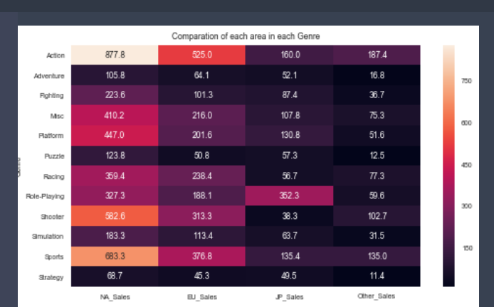

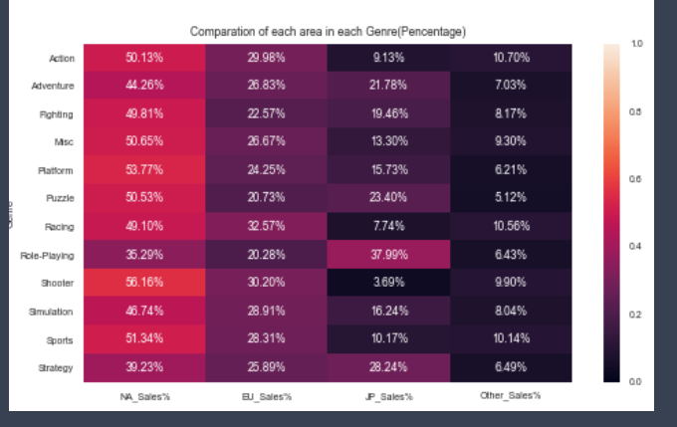

In the pictures above you can see the sales from the past 20 years ( 1986 to 2016). It is visible where, in the past, certain genres have already excelled. You might want to think that this trend will probably continue, but it might now be the case for the last few year, and for the next few years. I intend to find out what the best earning genre will be for the next 2 years.

While the client is mainly an European based company, the were also very interested in the popular genres of other regions for when they want to expand their company into other regions. It is then my client’s question if they should continue investing in the European market, or switch to another market.

# 4.0 KPI’s and metrics

Regarding the business and problem of the client, I decided to predict what market will be to most popular and profitable in the next two years. . Therefore, I need the concrete objectives and milestones for our project, so they can lead us to the right way. In this chapter, I’ll specify the KPI’s and Metrics of our project and explain their meaning and how I can measure the results.

* I want to predict what market will be popular and profitable In the next two years.
  + This can be achieved by looking at the data from the last years, and based on that data predicting the next few years.
* I want to increase the annual income of the client company by 5% compared to last years income.
  + This can be achieved by completing the goal of accurately predicting the popular and profitable genres for the next two years. After one year, there should already be an increase of 5% in the annual profits.

# 5.0 Analysis

In this chapter I will examine each 7 analytics topics in more details;

## 5.1 Assumptions

Assumptions are certain situations that I can expect to be true before starting the project. These assumptions must be true, otherwise I are unable to work further on the project:

* + I assume that the company has a budget to invest in our idea.
    - This way I know that, should our idea get approved, I can work on the project I had in mind without finances hindering us.
  + I assume that the data is accurate and real.
    - This way I can confidently work with the data without being insecure about the dataset.

## 5.2 Scope

For this case my business scope is centered in focusing on market profitability prediction. The Technical tools and knowledge I will use are centered on machine learning regression. This will all be done for the benefit for costumers and high management.

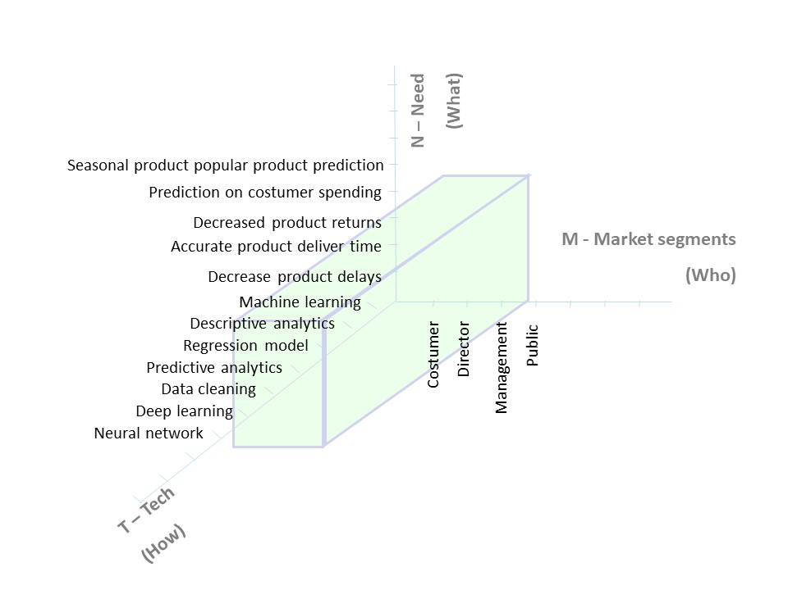

The timeframe of the dataset I received is all sales from 14600 video games from the years 1986 to 2016. This is the data I will use to base my predictions upon and all other data will be in the same timeframe.

The technologies I am going to be using to support and finish our project contain the following products and software:

* Python 3.x programming language; I use this to make the predictions and do the Machine Learning itself. I use this because it’s the language I learned to use in the classes and this is the easiest and most streamlined language for Machine Learning.

## 5.4 Data sources and methods

The data sources that I will be using in the project is mainly the data I received from the client. This is the game sales data from 1986 to and including 2016 September 21st This will be the main data I will be using. I might use other datasets if I can find any reliable, but they will only be used to improve predictions.

Prediction wise, as my prediction will be a continuous value, I’m planning to use regression instead of classification. I will start off but using the following three algorithms :

* Linear Regression
* Decision tree regression
* SVR

The label that will be valuable will of course the different sales. Further correlation research needs to be done in order to be sure which ones will be useful for the prediction.

## 5.5 Cost/ Benefit Analysis

Implementing the market profitability prediction for the client is both beneficial and costly at the same time. I expect the prediction algorithm to be as accurate as possible so that the net income of the company can eventually increase. However, it should be reminded that the prediction algorithm itself costs a lot to be maintained after introduction, not even mentioning that a big financial investment is necessary in the first place to initially build the system. In this chapter, I will introduce which costs and benefits would be caused by implementing the prediction algorithm in detail.

Direct Costs

* Consulting fees and the actual payments for the data scientist
* System maintenance cost for collecting and cleaning the data

Indirect Costs

* Initial and ongoing training for the proper use of the machine learning algorithm
* Labor hours for implementation the algorithm

Benefit description

* Increased customer satisfaction
* Increased total annual income

## 5.6 Risk

Every business always has some sort of risk. The business case is focused on predicting the most profitable market. However, it is not guaranteed that I can accurately predict the most profitable market. The points mentioned above are risks that I can expect from our analysis because I are uncertain if I will truly obtain the right prediction.

## 5.7 Conclusion

With all the methods, benefits, costs and risks taken in consideration, I can be certain of the actions I plan to take. I will ensure that the benefits will outweigh the ethical and cost-effective risks. Given our selected scope for the solution, I have a clear vision on the what and how factors concerning our case for you. I can’t say for sure if I will get accurate results, but even a slightly accurate case will most definitely be very helpful for the company in the future.